# Week-end Special Khajuraho Tour

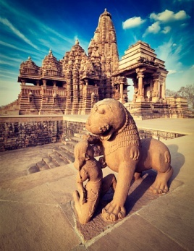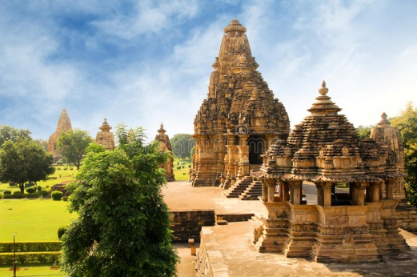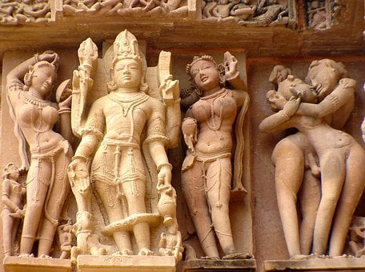

(**1 Nights & 02 Days)**

**Day 01: Arrival Khajuraho**

Arrival at Khajuraho Railway station around 0900 hrs. Upon arrival pick up from Railway station and transfer to hotel. After freshen up proceed full day guided tour to world heritage monuments of Western, Eastern & Southern group of temples. Enjoy light and sound show/folk dance show. Overnight stay at hotel.

**Day 02: Khajuraho - Departure**

First half of the day is free for leisure. You can opt an early morning jungle safari tour of Panna National Park. After lunch proceed for an excursion tour to Raneh Fall. Then transfer directly to Railway station to catch the train.

**Estimated Package Price: Rs. 7500/- per person (based on minimum 02 pax)**

**Inclusions:**

* AC accommodation for 01 night in 3 star equivalent hotels.
* All transfers and sight seeing by AC deluxe vehicle.
* 01 day guided tour of temples,.
* All parking, toll and driver allowances
* GST
* **Exclusions:**
* Entrance fees to monuments, national park etc.
* Optional tour cost
* Any extra services, tips, laundry, Camera and video fees
* Any other services not specifically mentioned under inclusions.

# Orchha- Khajuraho Tour

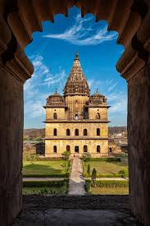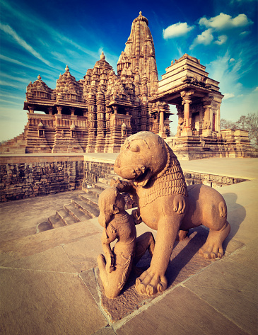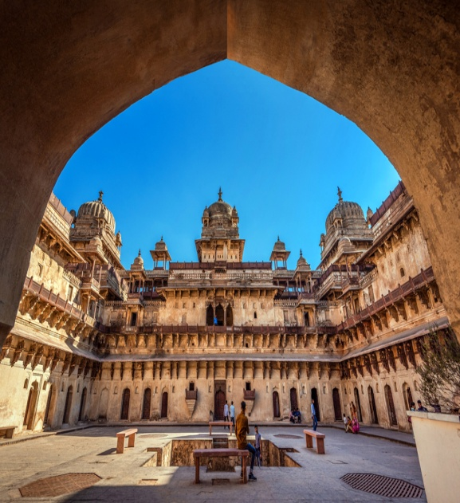

(**2 Nights & 03 Days)**

**Day 01: Arrival Jhansi – Orchha - Khajuraho**

Arrival Jhansi Railway station in morning. Upon arrival pick up from Railway station and procced by road to Orchha. Visit Ram Raja temple, Chaturbhuj temple and Jahangir Mahal. In late afternoon continue drive to Khajuraho. On arrival check into hotel. Overnight stay at hotel.

**Day 02: Khajuraho**

Today after breakfast proceed to full day guided tour of word heritage monuments of Khajuraho including Western, Eastern and Southern group of temples. In evening enjoy light and sound show at Western Group of temples. Overnight stay at hotel..

**Day 03: Khajuraho – Jhansi - Departure**

First half of the day is free for leisure. You can opt an early morning jungle safari tour of Panna National Park. Around 1100 hrs check out the hotel and start drive to Jhansi. Drop at Jhansi Railway station to catch your return scheduled train.

**Estimated Package Price: 8000 /- per person (based on minimum 09 pax)**

**Inclusions:**

* AC accommodation in 3 star equivalent hotels.
* All transfers and sight seeing by AC deluxe vehicle.
* 01 day guided tour of temples,.
* Half day guided tour of Orchha monuments.
* All parking, toll and driver allowances
* GST
* **Exclusions:**
* Entrance fees to monuments, national park etc.
* Optional tour cost
* Any extra services, tips, laundry, Camera and video fees
* Any other services not specifically mentioned under inclusions.

# Medieval Culture With Wildlife Tour

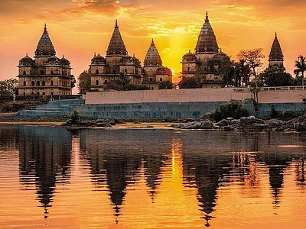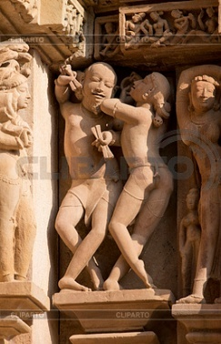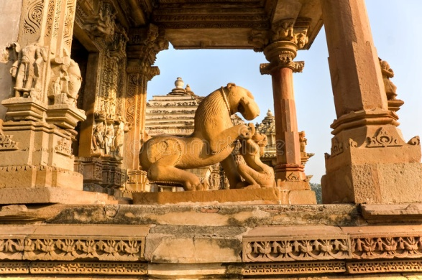

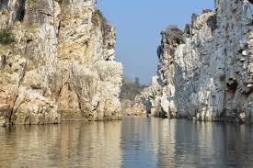 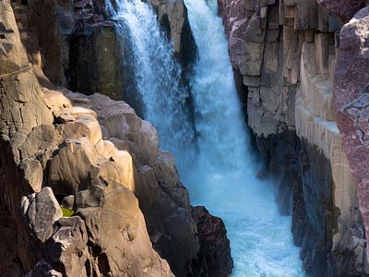

(**4 Nights & 05 Days)**

**Day 01: Arrival Jhansi – Orchha**

Arrival Jhansi Railway station in morning. Upon arrival pick up from Railway station and proceed by road to Orchha. Upon arrival check into hotel. Later full day orchha tour including visit Ram Raja temple, Chaturbhuj temple and Jahangir Mahal. Overnight stay at Orchha.

**Day 02: Khajuraho**

Today after breakfast proceed by road to Khajuraho. Upon arrival check into hotel and then guided tour of word hertoage monuments of Khajuraho including Western & Eastern group of temples. In evening enjoy light and sound show at Western Group of temples. Overnight stay at hotel..

**Day 03: Khajuraho – Bandhavgarh**

First half of the day is free for leisure. You can opt an early morning jungle safari tour of Panna National Park. Around 1100 hrs check out the hotel and start drive to Bandhavgarh. Arrival Bandhawgarh in evening. Check into your resort for overnight stay.

**Day 04: Bandhavgarh**

Enjoy an early morning Jungle Safari in Bandhavgarh national park to cite the Tiger and other wild animals. Return back to resort in afternoon. Evening at leisure. Overnight stay at hotel.

**Day 05:** **Bandhavgarh – Jabalpur - Departure**

After breakfast start drive to Jabalpur. En-route visit to famous Dhuandhar water fall Bhedaghat. Then transfer to railway station/Airport to continue your return journey to your respective destination.

**Estimated Package Price: Rs. 22000 ./- per person (based on minimum 02 pax)**

**Inclusions:**

* AC accommodation in 3 star equivalent hotels.
* All transfers and sight seeing by AC deluxe vehicle.
* 01 day guided tour of temples at Khajuraho.
* 01 day guided tour of Orchha monuments.
* All parking, toll and driver allowances
* GST
* **Exclusions:**
* Entrance fees to monuments, national park etc.
* Optional tour cost
* Any extra services, tips, laundry, Camera and video fees

Any other services not specifically mentioned under inclusions

# Divine Central India Tour

(**7 Nights & 08 Days)**

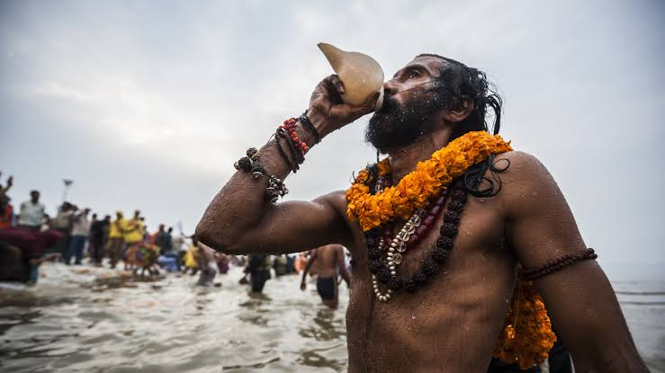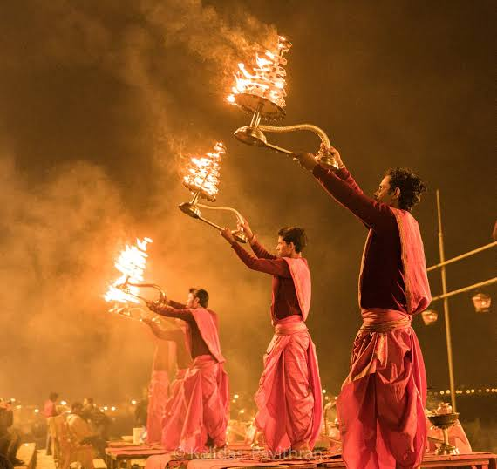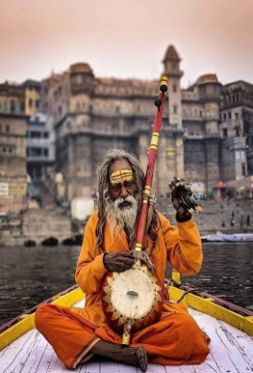

**Day 01: Arrival Khajuraho**

Pick up from Khajuraho railway station and transfer to hotel. After freshen up full day sightseeing tour of word heritage monuments of Khajuraho including Western, Eastern and Southern group of temples. In evening enjoy light and sound show at Western Group of temples. Overnight stay at hotel..

**Day 02: Khajuraho**

Proceed for an early morning jungle safari in Panna National Park. After jungle safari sight seeing of Raneh fall. Return back to hotel in late afternoon. Relax and overnight stay at hotel.

**Day 03: Khajuraho - Chitrakoot**

After breakfast start drive to Chitrakoot. En-route visit Kalinjer fort. On arrival check into hotel at Chitrakoot. Overnight stay at hotel.

**Day 04: Chitrakoot**

Today after breakfast proceed for full day sightseeing of Chitrakoot including visit to Ramghat, Kamadgir temple, Sita Rasoi, Sati Anusuiya & Gupt Godavari. Overnight stay at Chitrakoot.

**Day 05: Chiitrakoot – Prayagraj**

After breakfast start drive to Prayagraj. Upon arrival half day city tour of Allahabad (Prayagraj) including visit to Sangam. In evening check into hotel for overnight stay.

**Day 06: Prayagraj – Varanasi**

After breakfast check out the hotel and proceed by road to Varanasi. Arrive in afternoon at Varanasi. Upon arrival check into hotel. Later visit to Kashi Vishwanath temple. Later witness Ganga Aarati. Overnight stay at hotel.

**Day 07: Varanasi – Sarnath – Departure**

After breakfast proceed check out the hotel and proceed for an excursion tour to Sarnath. Visit the Dhamik Stupa, Chaukhandi Stupa and Sarnath Museum. Later return back to Varanasi. Transfer to Railway Station/Airport to continue your return journey.

**Estimated Package Price: Rs. 24000 ./- per person (based on minimum 10 pax)**

**Inclusion**

* AC accommodation in 3 star equivalent hotels.
* All transfers and sight seeing by AC tempo traveller vehicle.
* 01 day guided tour of temples at Khajuraho.
* 01 day guided tour of Varanasi monuments.
* All parking, toll and driver allowances
* GST
* **Exclusions:**
* Entrance fees to monuments, national park etc.
* Optional tour cost
* Any extra services, tips, laundry, Camera and video fees

**Tour Ends Here**